jsone-ld

http://json-ld.org/playground/

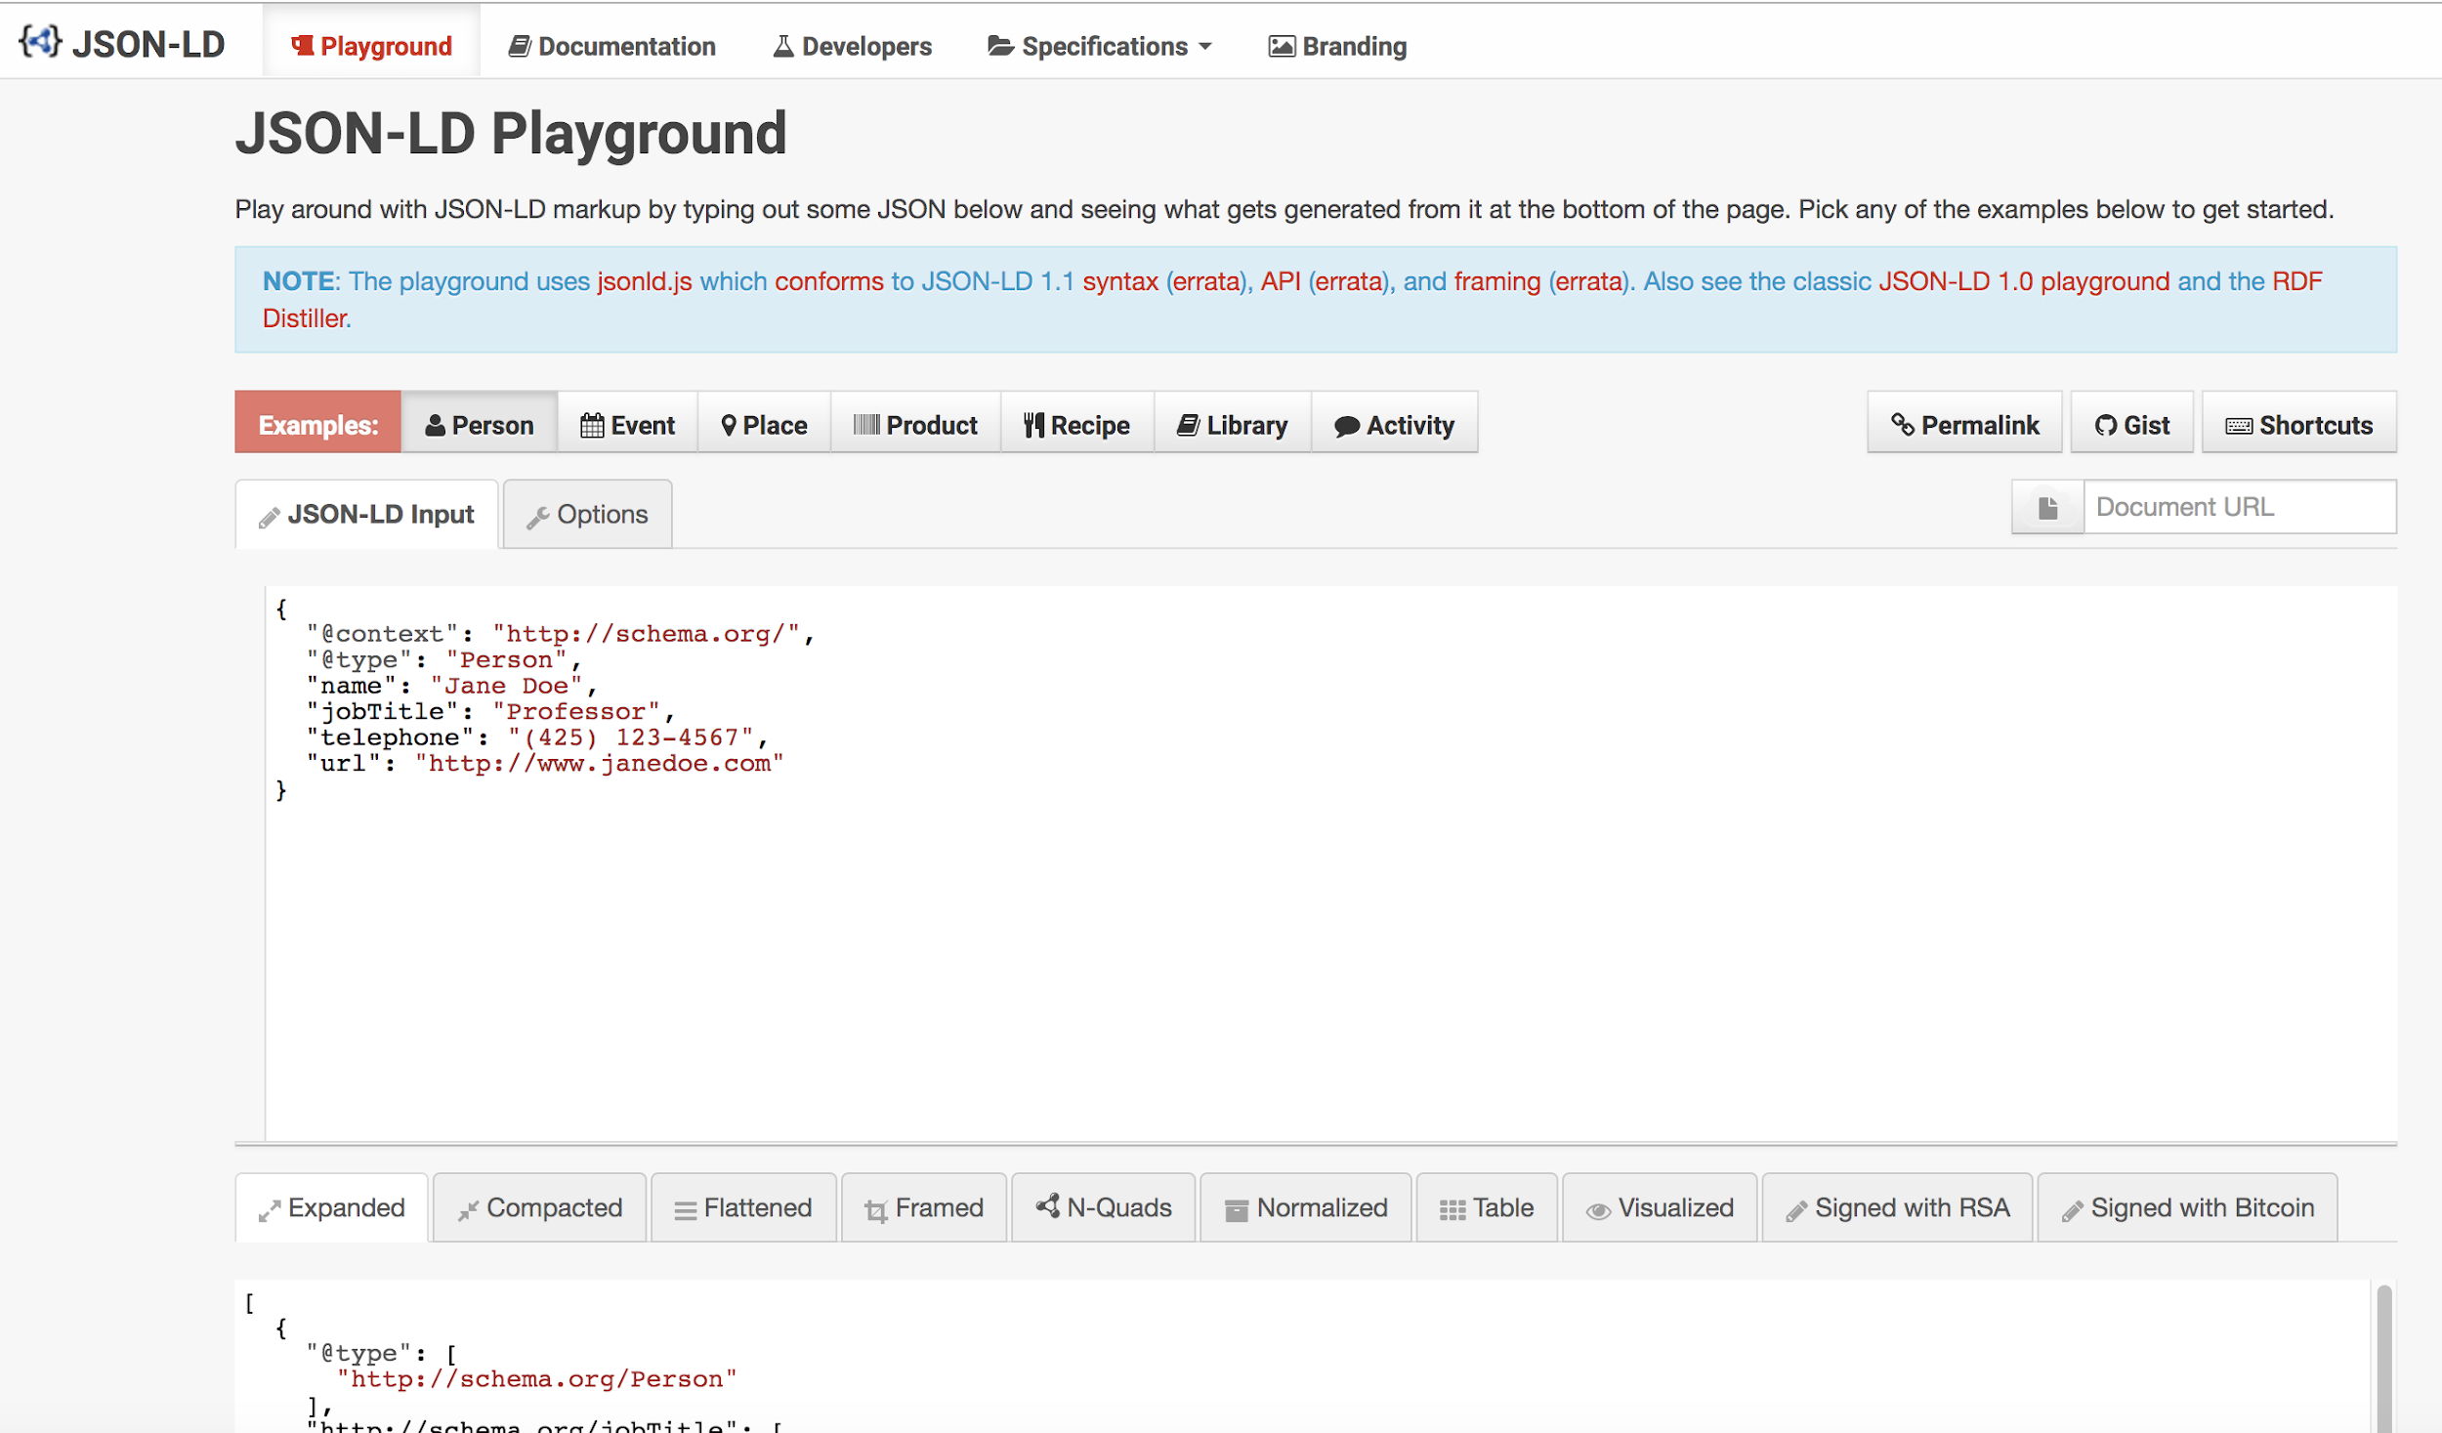

Hydra

http://www.markus-lanthaler.com/hydra/

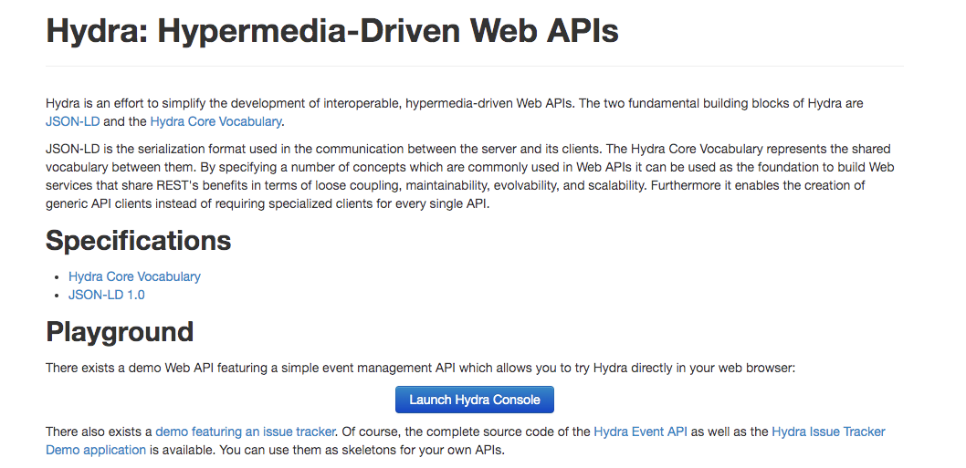

http://www.twilio.com/docs/errors/20003

